NSE Ticker Metadata Pipeline — Technical Design Document
Sep 28, 2026 · Author: @Deba

Overview
A daily batch pipeline that fetches the NSE equity universe (ticker, market cap, listing date), filters it down to a configurable set of market-cap buckets, and maintains a rolling top-N ticker list per bucket for downstream consumption by the Ticker Data System and Artifact Handler.
Runs entirely on a single Windows machine, once daily after NSE market close, as five independently-scheduled Docker containers coordinated through Windows Task Scheduler and a shared health flag — no cloud infrastructure, no message queue, no database.
Stages:
- Data Source — fetches and joins the raw NSE data, writes a dated snapshot
- Filter — excludes recently-listed tickers, buckets by market cap, keeps top-N per bucket
- Ticker Metadata Storage — the durable per-bucket CSV store Filter writes into
- Cleaner — quarterly retention sweep over both stores
- Notifier — health check that gates whether the other stages proceed

Architecture
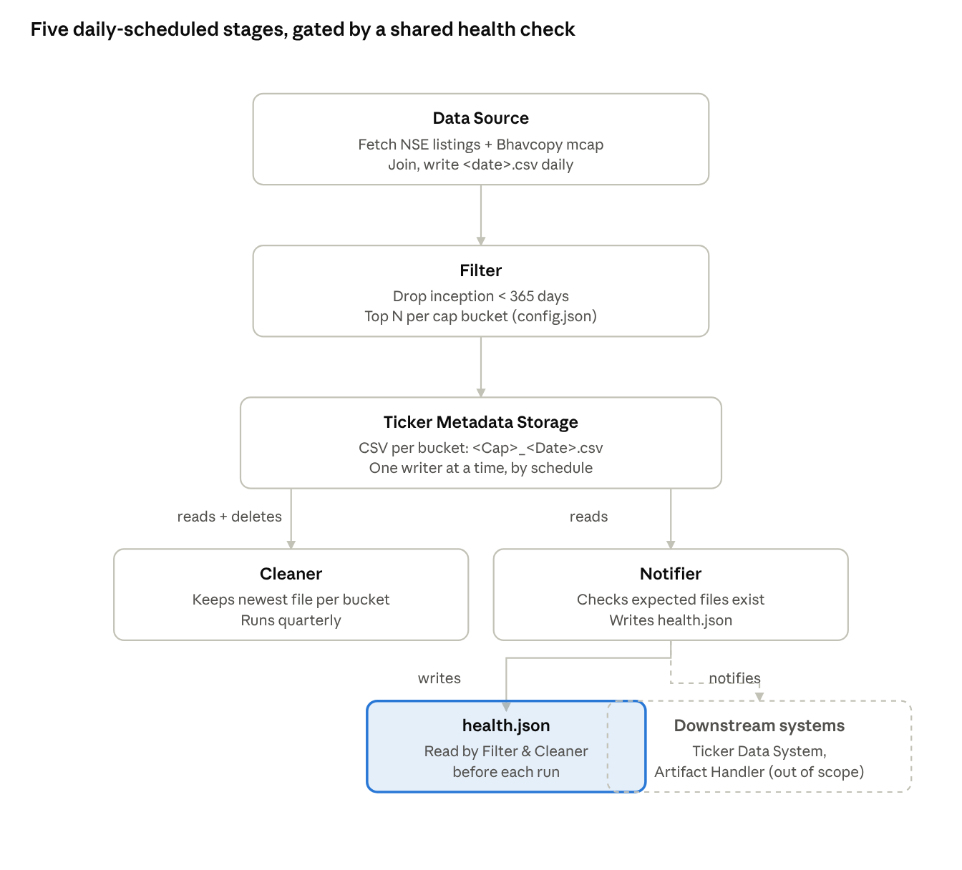
five-stage pipeline · health-gated
Data flows top-down through five daily stages; Notifier's health.json gates Filter and Cleaner before each run, and separately notifies the two out-of-scope downstream systems.

Data Source
Runs daily, after NSE market close (config-driven trigger time; NSE bhavcopy typically posts by ~19:00 IST).
Steps:
- Fetch the ticker/listing-date master list from https://nsearchives.nseindia.com/content/equities/EQUITY_L.csv (columns of interest: SYMBOL, DATE OF LISTING).
- Fetch https://www.nseindia.com/api/daily-reports?key=CM, locate the Bhavcopy (PR)(zip) entry, download the zip from its filePath + fileActlName, and extract the file with an mcap prefix (columns of interest: symbol, market cap).
- Establish a browser-like session before both requests (fetch the NSE homepage first to pick up cookies, set a realistic User-Agent and Accept headers) — NSE blocks bare scripted requests.
- Retry each request up to 3 times with exponential backoff (e.g. 2s/4s/8s) on network or HTTP errors.
- Inner-join the two datasets on ticker symbol. Any symbol present in only one file is dropped and logged as a warning — this is expected (index/series differences) and does not fail the run.
- Write the combined table (Symbol, MarketCap, InceptionDate) to app/data/raw/<current_date>.csv.
On failure (session/fetch never succeeds after retries): log the error and exit non-zero. No alert is sent (no Telegram/notification integration for this pipeline) — failure surfaces via the Windows Task Scheduler task's own failed-run status, and via Notifier's health check on the next run finding no new raw file.

Filter
Source: app/data/raw/<current_date>.csv (today's Data Source output) · Destination: Ticker Metadata Storage
Runs immediately after Data Source in the daily chain, but only if health.json (written by yesterday's Notifier run) reports healthy — otherwise it logs and exits without writing.
Steps:
- Read today's raw CSV; drop any row where DATE OF LISTING is less than 365 days before today (recently-listed tickers are excluded from bucketing).
- Read cap-bucket thresholds and target counts from config.json (any number of buckets — LargeCap, MidCap, SmallCap — temporarily fixed with N = 50 each — each with its own market-cap threshold and its own top-N, so this generalizes beyond a fixed two-bucket split).
- For each bucket, in descending threshold order, select tickers whose market cap falls in that bucket's range, sort descending by market cap, and keep the top N for that bucket (ties broken by symbol, ascending, for determinism).
- Write one file per bucket to Ticker Metadata Storage: app/data/storage/<BucketName>_<current_date>.csv.

Ticker Metadata Storage
Source: Filter
Property | Value
Location | app/data/storage/
Naming | <BucketName>_<Date>.csv (e.g. LargeCap_2026-09-28.csv), one file per bucket per day
Contents | Symbol, MarketCap, InceptionDate for that bucket's top-N tickers that day
Retention | New dated file written daily; old files accumulate until Cleaner sweeps (current design, confirmed) — up to ~90 files per bucket between quarterly sweeps
Concurrency | No explicit file lock. Safe because Task Scheduler runs Data Source → Filter → Cleaner → Notifier as non-overlapping scheduled entries; no two stages ever write concurrently. If the schedule is ever changed to allow overlap, this assumption must be revisited.

Cleaner
Source → Destination: Ticker Metadata Storage → Ticker Metadata Storage (reads and writes back in place)
Runs every 3 months (quarterly, e.g. 1st of Jan/Apr/Jul/Oct). Scope was extended beyond the original doc: it now sweeps both stores, confirmed with you:
- Ticker Metadata Storage (app/data/storage/): for each bucket prefix (LargeCap_*, MidCap_*, SmallCap_*), keep only the file with the most recent date and delete the rest.
- Data Source raw output (app/data/raw/): keep only the most recent <date>.csv and delete the rest, on the same quarterly schedule.
Runs only if health.json reports healthy; otherwise logs and exits without deleting anything (a stale/unhealthy state should never trigger destructive cleanup).

Notifier
Source: Ticker Metadata Storage · Destination: Ticker Data System, Artifact Handler (both out of scope for this TDD — documented only as consumers)
Runs last in each day's chain (and after each quarterly Cleaner run).
- Checks that today's expected bucket files exist in app/data/storage/ (one per configured bucket) and that the raw file for today exists in app/data/raw/.
- Writes app/data/health.json: {"status": "healthy" | "unhealthy", "checkedAt": "<ISO timestamp>", "missing": [...]}
- Gating mechanism: Filter and Cleaner each read health.json at the start of their own run and exit immediately (logging why) if status is not healthy. This makes the health check a real gate rather than a purely informational log line — the proposed design you chose over a minimal end-of-chain check.
- If healthy, it notifies the Ticker Data System and Artifact Handler that fresh data is available (mechanism — webhook, file drop, etc. — is out of scope; those systems' own designs are not covered here).

Configuration
Lives at app/config/config.json. Proposed schema (placeholder threshold/N values — tune after review):
{
"filter": {
"minInceptionDays": 365,
"capBuckets": [
{ "name": "LargeCap", "minMarketCap": 2000000000000, "topN": 50 },
{ "name": "MidCap", "minMarketCap": 500000000000, "topN": 50 },
{ "name": "SmallCap", "minMarketCap": 100000000000, "topN": 50 }
]
},
"paths": {
"rawData": "app/data/raw",
"storage": "app/data/storage",
"health": "app/data/health.json"
},
"nse": {
"equityListUrl": "https://nsearchives.nseindia.com/content/equities/EQUITY_L.csv",
"dailyReportsUrl": "https://www.nseindia.com/api/daily-reports?key=CM",
"maxRetries": 3,
"backoffSeconds": [2, 4, 8]
},
"schedule": {
"dailyRunTime": "19:30",
"cleanerCron": "0 20 1 1,4,7,10 *"
}
}
capBuckets is an ordered, arbitrary-length list — add or remove buckets without code changes. minMarketCap is in rupees; buckets are evaluated in the order listed, so list them highest threshold first.

Deployment & Orchestration
Property | Value
Language | Python
Host | Windows machine, local only — no cloud, no server
Packaging | One Docker image containing all four stage scripts (data_source.py, filter.py, cleaner.py, notifier.py)
Trigger | Windows Task Scheduler, one entry per stage, each running docker run --rm -v C:\ProgramData\ticker-pipeline\data:/app/data -v C:\ProgramData\ticker-pipeline\config:/app/config <image> python <stage>.py
Daily order | Data Source → Filter → Notifier, staggered a few minutes apart after NSE close so each finishes before the next starts
Quarterly order | Cleaner → Notifier, on the 1st of Jan/Apr/Jul/Oct
Volumes | Host folders C:\ProgramData\ticker-pipeline\data and \config are bind-mounted into every container run, so files persist across the ephemeral per-stage containers (default path — confirm or override before implementation)
Concurrency guard | None beyond the fixed, non-overlapping Task Scheduler times (see Ticker Metadata Storage)

Error Handling & Logging
- Every stage logs to a local file (e.g. app/data/logs/<stage>_<date>.log) and to stdout (visible in Task Scheduler's run history).
- Data Source: session + retry with backoff on fetch failures; log-only on final failure (no alert channel).
- Filter/Cleaner: exit early and log if health.json is unhealthy; otherwise no special handling beyond standard exceptions.
- Join mismatches (symbol in one file but not the other): dropped and logged as warnings, not failures.
- No Telegram or other alerting is wired into this pipeline (unlike the Swing-Trading-System) — failures are visible via Task Scheduler history and health.json, not pushed.

Open Items / Assumptions Log
Decisions made while clarifying this TDD, recorded here for traceability:
# | Question | Decision
1 | Runtime | Python
2 | Orchestration | Windows Task Scheduler + Docker, local machine only, one image / one Task Scheduler entry per stage
3 | Run frequency | Daily, after market close
4 | Cap buckets | Arbitrary number of buckets (X1, X2, X3…), thresholds + top-N per bucket in config.json
5 | File locking | No explicit lock — relies on non-overlapping schedule
6 | Fetch resilience | Session + retry with backoff; log-only on failure, no alerting
7 | Storage accumulation | Dated file per bucket per day (as originally written); Cleaner sweeps quarterly
8 | Cleaner scope | Extended to also sweep raw Data Source output, same quarterly schedule
9 | Health gating | health.json is a real gate: Filter and Cleaner check it before running
10 | Volume mapping | Fixed bind-mounted host folder (default C:\ProgramData\ticker-pipeline) — confirm exact path before implementation
11 | Join mismatch | Inner join; unmatched symbols dropped and logged
12 | config.json schema | Drafted above with placeholder values; real thresholds/N still to be set
Still open before implementation: exact market-cap thresholds and N values per bucket, exact daily run time, and confirmation of the host bind-mount path. N per bucket is no longer open — temporarily fixed at 50 for LargeCap, MidCap, and SmallCap.

